**Classroom Behavior Policy**

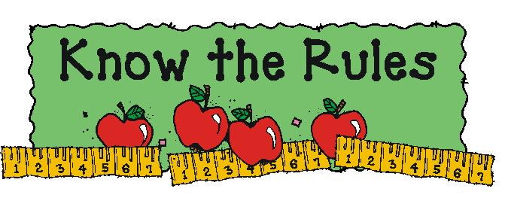

**Classroom Rules**  
1. Stay in your seat unless you have permission to be up.   
2. Keep your hands, feet and objects to yourself.   
3. Follow directions the first time.   
4. Do not talk while others are talking.   
5. Be respectful.   
6. DO YOUR BEST!!  
  
**Classroom Management**  
  
In order to maintain a positive and structured learning environment, I use the “pull a card” behavior system. I will need your help as a parent to reinforce the behavior that I expect from your child.   
  
Each child starts off on white and has a 100 in conduct for the week. If a student breaks a rule, their card color will be changed to green and will result in a 5-point conduct grade loss for the week. If behavior continues to be an issue, the student will then move their card to blue, which will result in a 10 point loss in conduct for the week. If behavior continues, the next card color is yellow, which is 15 points off their weekly grade. The final card color is red, which is 20 points off in conduct for the week and parent contact.

The student's color will be recorded each day on their monthly behavior sheet located on the back of their folder. This allows for parent/teacher communication DAILY. Parents will need to sign the behavior chart each day. **If there is no color written, that means your child was on white ☺**The next day, each student will start back over on white. HOWEVER, points that were deducted from the previous day will still come off of their weekly conduct grade given on Fridays.

**Card colors in order of movement:**

White

Green (Warning- 5 points off conduct/5 minutes of recess)

Blue (10 points off conduct/10 minutes of recess)  
Yellow (15 points off conduct/no recess)   
Red (20 points off conduct/no recess/loss of Friday activity/parent contact)